Company OS Universal Integration Control Plane and Execution Architecture

Executive summary
The correct architecture for the Company OS is not one large integration product and not a direct collection of point-to-point connectors.
It should be a Company OS-owned Integration Control Plane above several specialized execution engines:
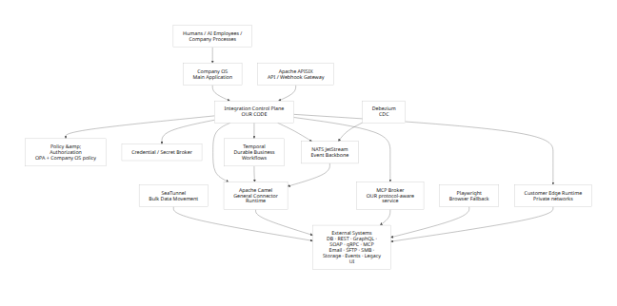
My recommendation after reviewing the current 2026 projects and releases is:
Responsibility | Recommended foundation | Decision
Integration product model | Our code | Must own
Connector/action/trigger contract | Our code | Must own
Tenant/company/portal policy | Our code + OPA | Must own
API ingress and webhook gateway | Apache APISIX | Reuse
General integration/protocol runtime | Apache Camel | Reuse
Durable multi-step workflows | Temporal | Reuse
Event backbone | NATS + JetStream | Reuse
Agent-facing external integrations | Native MCP broker | Build on MCP SDK/spec
Database change capture | Debezium | Reuse
Bulk/large-volume data synchronization | SeaTunnel | Add when needed
Browser-only legacy systems | Playwright | Last-resort worker
Visual integration designer | Kaoto code/concepts | Reuse selectively
Ready-made SaaS connector logic | Activepieces Pieces | Harvest/adapt selectively
Policy engine | Open Policy Agent | Reuse
SBOM generation | Syft | Reuse
Vulnerability scanning | Grype or equivalent | Reuse
Artifact signing | Cosign | Reuse
This design deliberately separates what the Company OS believes an integration means from how a specific system happens to implement it.
An AI employee should ask for:
crm.contact.search
crm.contact.update
invoice.read
invoice.create
document.search
email.send
calendar.event.create
project.create
It should not normally need to know that Company A uses REST, Company B uses PostgreSQL, Company C exposes MCP, and Company D can only be automated through a browser.
That abstraction is the critical product asset.

Main conclusions
Apache Camel should be the broad connector/protocol engine. Camel's current 4.18 LTS catalog includes JDBC/SQL, REST/OpenAPI, GraphQL, gRPC, Kafka, web services, SFTP and many other integration components; its REST OpenAPI component can consume OpenAPI 3.x descriptions. [1] The current supported LTS is 4.18.x; 4.18.3 was released in July 2026, while 4.21.0 is the newer feature release. The project also publishes CycloneDX SBOMs for modern releases. [2]
APISIX should be the north-south API/webhook gateway, not the integration engine. Version 3.17.0 was released June 15, 2026 and added stricter authentication/TLS behavior, new access controls, GraphQL traffic controls, data-protection features and other gateway improvements. It is Apache-2.0 licensed. [3]
Temporal should own long-lived orchestration. Temporal Server 1.31.2 is current as of August 10, 2026, is MIT licensed, and exists specifically to execute durable workflows that survive failures and retry failed activities. [4]
NATS JetStream should be the default internal event backbone, but we should design the business layer around at-least-once delivery plus idempotency, not advertise magical exactly-once business effects. JetStream provides persistence, replay, replicated streams and at-least-once consumption, and it provides message deduplication/double-ack mechanisms for stronger delivery semantics. Application-level idempotency is still necessary. [5]
MCP should be a first-class integration type but should not replace ordinary APIs. The July 28, 2026 MCP specification is the current release and moves the protocol toward a stateless HTTP-friendly architecture. MCP tools are explicitly designed to let models invoke external systems, and the specification requires serious consent and authorization controls. [6]
Debezium should handle database CDC rather than us inventing CDC. Debezium 3.6.1.Final was released August 4, 2026 and includes integrity/security fixes. The stable release supports major database families and can also be embedded through the Debezium Engine API. [7]
SeaTunnel should remain an optional specialist engine. Version 2.3.13 is current in the retrieved release stream and is designed for distributed, high-volume data integration. Its JDBC sink supports both batch and streaming execution and can use XA for stronger write guarantees where the database supports it. [8]
Playwright belongs at the bottom of the preference ladder. Playwright 1.62.1 is current as of this research, Apache-2.0 licensed, and supports Chromium, Firefox and WebKit. It is excellent automation infrastructure, but browser automation is inherently more fragile than a stable programmatic interface. [9]
The most important deployment capability that should be added to the previous design is a Customer Edge Integration Runtime. Many of the businesses we want to serve will have databases, SMB shares, SFTP servers, old ERP systems and internal APIs that cannot safely be exposed to the Internet. The Company OS should therefore support a small customer-hosted runtime that makes outbound authenticated connections to our control plane and executes approved integrations inside the customer's network.
That dramatically expands what “integrate with anything” means without requiring customers to open inbound database ports to us.

Integration coverage and priorities
The platform should not treat all integration mechanisms as equal. There should be a preference order based on stability, security and maintainability.

Recommended integration preference
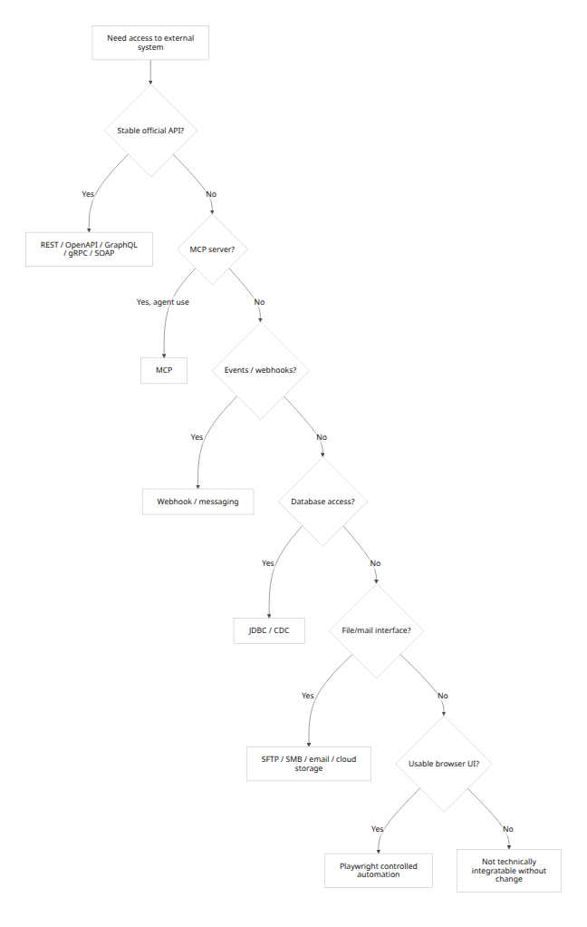
This ordering is not absolute. For example, CDC may be preferable to a poorly designed polling API, and MCP may be the official interface supplied by a modern AI-oriented product.

Priority tiers
Priority | Integration family | Typical purpose | Primary runtime
P0 | REST / OpenAPI | Most SaaS and modern business systems | Camel
P0 | Webhooks | Immediate incoming events | APISIX + Control Plane
P0 | JDBC / SQL | Legacy/on-prem databases, analytics, controlled writes | Camel
P0 | MCP | Agent-facing tools/resources | Native MCP Broker
P0 | Email | Mailboxes as business interfaces | Camel
P0 | Files / SFTP / SMB | Legacy exchange, imports/exports | Camel
P0 | Cloud object/file storage | Documents, exports, archives | Camel/native connector
P1 | GraphQL | Schema-driven SaaS APIs | Camel/native HTTP
P1 | gRPC | Internal services and modern infrastructure | Camel/APISIX
P1 | SOAP / XML web services | ERP, financial, government and legacy enterprise | Camel
P1 | Messaging | NATS, Kafka, AMQP/JMS, MQTT | Camel + native bus
P1 | CDC | Near-real-time DB change streams | Debezium
P2 | Bulk/ETL/ELT | Millions of rows / historical migrations | SeaTunnel
P2 | Streaming data pipelines | Continuous high-volume movement | SeaTunnel / Kafka / NATS depending workload
P3 | Browser automation | Systems with no usable interface | Playwright
Camel 4.18 LTS directly covers a large fraction of this table. Its component catalog includes GraphQL, gRPC, JDBC/SQL, Spring Web Services, REST/OpenAPI, Kafka and numerous SaaS/cloud integrations. Its broader catalog also lists Google Drive, Google Mail, Google Sheets, Google Storage and similar services. [10]
Its GraphQL implementation is currently a client supporting queries and mutations but not GraphQL subscriptions, so GraphQL subscriptions should be handled separately if a vendor requires them. [11]
Camel's REST OpenAPI support handles OpenAPI 3.x, not old Swagger 2.0, so the Connector SDK should contain a normalization/conversion step for legacy Swagger descriptions. [12]

What “integrate with anything” honestly means
There is no software platform that can literally integrate with every external system.
An external system needs at least one usable surface:
API
OR
MCP
OR
event/webhook
OR
database protocol
OR
message protocol
OR
mail
OR
file exchange
OR
browser/interface that can be automated
If a system is physically unreachable, exposes no interface, and cannot be automated through its UI, integration is impossible until something changes at that system.
Our goal should therefore be:
Support every major class of interface, with a controlled fallback ladder.

Direct database integration
For relational systems, JDBC should be our generic protocol.
Camel's JDBC and SQL components let routes execute database operations through a supplied datasource. [13]
A database connection should contain:
DatabaseConnection
├── engine / driver
├── host
├── port
├── database
├── TLS policy
├── credential_ref
├── allowed schemas
├── allowed tables
├── allowed operations
├── query timeout
├── concurrency limit
├── connection pool policy
└── execution location
Execution location is important:
Cloud reachable database
→ Company OS connector worker
Private database
→ Customer Edge Runtime
High-security database
→ Dedicated tenant worker
For AI-facing access, arbitrary SQL should not be the default.
Instead:
AI Employee
↓
finance.invoice.search
↓
Capability Service
↓
Approved parameterized query
↓
Database
This avoids giving a model unrestricted SQL authority.

REST and OpenAPI
REST/OpenAPI should be the easiest connector type to create.
An import wizard should accept:
OpenAPI URL
OpenAPI file
API base URL
Authentication configuration
Then generate draft:
- Operations.
- Input/output schemas.
- Capabilities.
- Authentication requirements.
- Retry rules.
- Rate-limit fields.
- Test requests.
Camel can construct REST producers from OpenAPI 3.x definitions. [12] APISIX 3.17 also provides OpenAPI request validation through its OAS validator functionality, which is useful at the ingress boundary. [14]
Generated operations must still be reviewed. An OpenAPI document generally does not tell us enough about:
- Business side effects.
- Idempotency.
- Approval risk.
- Vendor quotas.
- Semantic meaning.
- Data sensitivity.
Those belong in our connector manifest.

Webhooks
Inbound webhooks should terminate at APISIX and our Webhook Ingress Service:
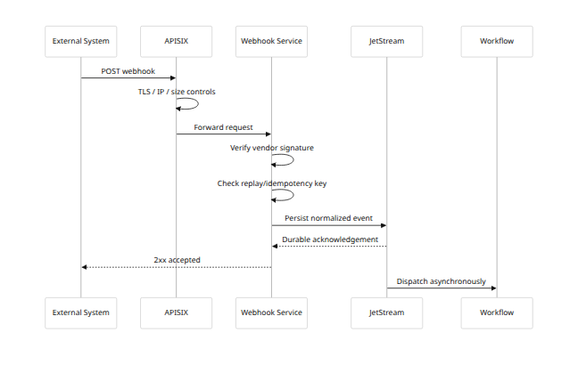
Where vendors support signed webhooks, the connector should supply signature verification.
For example, Frappe's current webhook mechanism can add an X-Frappe-Webhook-Signature containing an HMAC-SHA256 signature when a webhook secret is configured. [15]

Email and files
Mail/file interfaces deserve first-class status rather than being treated as old-fashioned exceptions.
A business integration might be:
New message arrives in invoices@company.com
↓
Validate sender
↓
Extract PDF
↓
Run document extraction
↓
Match supplier
↓
Create review task
↓
Post approved invoice
Similarly:
Supplier writes:
/outbound/orders_2026-08-10.csv
↓
SFTP watcher
↓
Validate checksum and schema
↓
Import
↓
Archive
↓
Emit OrderImportCompleted
Camel supplies SFTP support and related file-transfer components. [16]

Public APIs for our own platform
A universal integration platform must itself be easy to integrate into.
Company OS should expose:
- REST/OpenAPI.
- Webhooks.
- MCP server.
- Event subscriptions.
- Bulk export/import.
- Eventually gRPC for internal/high-volume clients.
This creates two directions:
External software
↕
Integration Fabric
↕
Company OS
not merely:
Company OS
↓
External software

Recommended open-source stack and deployment architecture
The following versions/statuses are current to the research date, August 10, 2026.
Project | Current/recommended status | License | Role in our architecture | Source
Apache Camel | 4.18.3 LTS recommended baseline; 4.21.0 current newer line | Apache-2.0 | General connector/protocol runtime | Downloads [2]
Apache APISIX | 3.17.0, June 15, 2026 | Apache-2.0 | API/webhook ingress, routing, auth, throttling | 3.17 release [3]
Debezium | 3.6.1.Final, August 4, 2026 | Apache-2.0 | CDC | 3.6.1 release [17]
Temporal Server | 1.31.2, July 8, 2026 | MIT | Durable orchestration | Repository [4]
NATS Server | 2.14.3, June 29, 2026 | Apache-2.0 | Internal event backbone / JetStream | Releases [18]
Apache SeaTunnel | 2.3.13, March 2026 | Apache-2.0 | Bulk/stream data movement | Releases [19]
Playwright | 1.62.1 | Apache-2.0 | Browser automation fallback | Repository [9]
Kaoto | 2.11, June 17, 2026 | Apache-2.0 | Visual Camel design / mapping inspiration or reuse | Repository [20]
Activepieces | 0.87.0, August 6, 2026 | MIT Community + commercial EE sections | Reusable TypeScript connector logic | Releases [21]
MCP specification | 2026-07-28 | MIT specification repository | Agent integration standard | Specification [22]
Open Policy Agent | Active project | Apache-2.0 | Fine-grained policy evaluation | Repository [23]

Apache Camel
Recommended role: generic execution adapter.
Use Camel for:
- HTTP.
- REST/OpenAPI.
- JDBC/SQL.
- SOAP.
- GraphQL.
- gRPC.
- SFTP/FTP.
- Mail.
- Kafka/JMS.
- Cloud storage.
- SaaS connectors.
- Enterprise protocols.
Camel should not own:
- Tenants.
- Company roles.
- Human/AI identities.
- Connections.
- Secrets.
- Business workflow definitions.
- Company-level permissions.
It should receive a narrow execution request:
{
"runId": "run_123",
"tenantId": "tenant_a",
"connectionHandle": "execconn_x",
"connector": "erpnext",
"connectorVersion": "2.1.0",
"capability": "finance.invoice.read",
"input": {
"invoiceId": "INV-1008"
}
}
and return a normalized result.
Strengths: extremely broad protocol coverage; mature routing patterns; support for circuit breakers and saga patterns; several deployment forms; OpenAPI tooling. Camel provides a Circuit Breaker EIP and Saga EIP in its current documentation. [24]
Weaknesses: Java ecosystem; significant surface area; easy to create overly complex routes; it is an integration framework rather than our desired product/control plane.
Version policy: use the newest patched LTS rather than blindly using the initial LTS release. For example, Camel's advisory for CVE-2026-46590 affected earlier 4.18 releases and is fixed in 4.18.3, illustrating why patch-level upgrades matter. [25]

Apache APISIX
Recommended role: public protocol boundary.
Use APISIX for:
- Public Company OS API.
- Incoming webhooks.
- External MCP-over-HTTP front door.
- Rate limits.
- Authentication adapters.
- TLS.
- Request-size rules.
- IP rules.
- Canary routing.
- OpenAPI validation.
- Gateway metrics.
APISIX's OIDC plugin can authenticate through OpenID Connect providers, and its OAS validator can validate requests against OpenAPI specifications. [26]
Do not turn APISIX into the entire authorization system. Gateway authorization is only the first layer.

Temporal
Recommended role: orchestration when business state must survive time and failure.
Example:
CustomerContractSigned
↓
Create CRM customer
↓
Create ERP customer
↓
Wait for Finance approval
↓
Create project
↓
Create document folder
↓
Assign onboarding AI
↓
Wait up to 72 hours for missing documents
↓
Escalate if necessary
The workflow might exist for days. Temporal is designed for durable workflows and automatic retries after intermittent failures. [4]
Temporal should not become the generic event bus or connector registry.
Namespaces can provide one technical level of logical isolation in a self-hosted Temporal deployment, but Company OS authorization must still be enforced above them. [27]

NATS and JetStream
Recommended role: internal event distribution.
Examples:
customer.created
invoice.updated
task.completed
integration.connection.failed
knowledge.updated
ai.action.completed
Use plain Core NATS only for ephemeral notifications where loss is acceptable.
Use JetStream whenever an event must be durable/replayable.
JetStream supplies persistent streams and consumers and is built for durable message processing. [28]
For critical flows, use three replicas at minimum as an architectural baseline, and test filesystem durability behavior explicitly. JetStream documentation discusses the tradeoff between replication and disk synchronization; stronger disk synchronization can be selected at a performance cost. [28]

Debezium
Recommended role: change capture from databases we do not control.
Example:
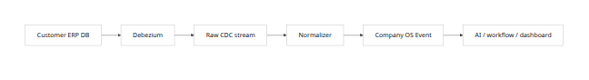
Debezium's stable connector set covers PostgreSQL, MySQL, MariaDB, SQL Server, Oracle, Db2, MongoDB and other supported stores. [29]

SeaTunnel
Recommended role: exceptional volume.
Do not route a 500-million-row migration through ordinary interactive Camel actions.
Use SeaTunnel for:
- Initial migration.
- Data warehouse loads.
- Large table copies.
- High-volume continuous synchronization.
- Large file pipelines.
SeaTunnel 2.3.13 supports distributed data-integration workloads and JDBC batch/stream sinks. [30]

Playwright
Recommended role: explicit fallback.
It should run in a dedicated browser-worker tier, not inside an API server or AI-agent runtime.
Playwright currently supports Chromium, Firefox and WebKit through one automation framework, and the current project is Apache-2.0. [9]

Kaoto
Kaoto is a useful source of:
- Camel flow visualization.
- Component property editors.
- Data mapping UI.
- Testing UI.
- Kamelet/component discovery.
The project describes access to hundreds of Camel components/Kamelets and visual data mapping, and is Apache-2.0 licensed. [31]
I would reuse or learn from Kaoto rather than expose Kaoto itself as the customer integration product.

Activepieces
Activepieces should be treated as a connector source ecosystem, not our architectural kernel.
Its Pieces system is TypeScript-based and the project reports more than 280 pieces; the Community Edition is MIT while enterprise areas are commercially licensed. [32] Version 0.87.0 was released August 6, 2026 and includes ongoing connector, OAuth, MCP, sandbox and workflow work. [33]
The rule should be:
Activepieces piece
↓
license/dependency review
↓
code/API recertification
↓
our compatibility wrapper
↓
our Connector Contract
Do not make our Connection, Tenant, Policy, Run or Flow objects depend on Activepieces internals.

Private-network Edge Runtime
This should be an important proprietary part of the architecture.
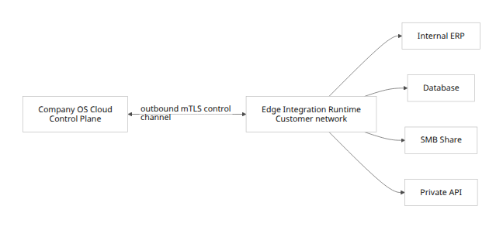
The customer should not normally need to expose:
5432 PostgreSQL
3306 MySQL
445 SMB
22 SFTP
internal ERP API
to the public Internet.
The Edge Runtime:
- Makes an outbound connection.
- Receives signed job/capability definitions.
- Gets only temporary credential handles.
- Runs selected Camel/native connectors.
- Sends normalized results/events back.
- Has no ability to browse unrelated tenant workloads.
- Can optionally execute Debezium locally.
- Can be customer-managed for high-security installations.
Support three deployment classes:
Class | Deployment
Standard SaaS | Shared control plane + multi-tenant isolated workers
Regulated/dedicated | Shared control plane + dedicated execution namespace/node pool
Private/on-prem | Edge runtime inside customer's network

Control plane, connector contract, security, tenancy, secrets, and MCP governance
The Integration Control Plane is the part we should build ourselves.
None of Camel, Temporal, APISIX, Activepieces, Debezium or SeaTunnel knows enough about our:
- Company.
- Portal.
- Departments.
- Human employees.
- AI employees.
- Delegation rules.
- Approval rules.
- Company knowledge.
- AI authority.
- Business context.

Core control-plane objects
The minimum durable model should contain:
Object | Purpose
Connector | Stable logical connector identity
ConnectorVersion | Immutable implementation version
Connection | Tenant-owned configuration for one external system
ConnectionCredentialRef | Reference to encrypted credentials
Capability | Normalized action/query/event
Trigger | Source of events/work
WorkflowDefinition | Business orchestration definition
WorkflowVersion | Immutable workflow revision
Mapping | Transformation definition
MappingVersion | Immutable mapping revision
ExecutionPolicy | Limits, approvals and risk rules
WebhookEndpoint | Managed incoming endpoint
Run | One workflow/integration execution
StepRun | One execution step
Checkpoint | Poll/CDC synchronization position
ExternalRecordLink | Maps IDs across systems
MCPServerConnection | External MCP endpoint
MCPToolSnapshot | Approved tool catalog/version
Artifact | Connector image/package and digest
EdgeRuntime | Registered private execution node
A Connection should never mean merely “a set of credentials.”
It should be:
Connection
├── tenant
├── owner/scope
├── connector
├── connector version policy
├── environment
├── endpoint
├── auth method
├── credential reference
├── enabled capabilities
├── rate limits
├── execution location
├── network restrictions
├── health
├── data classification
└── policy

Capability abstraction
The most strategically important model is Capability.
Vendor operations can map to a semantic capability:
Twenty API
POST /rest/companies
│
▼
crm.company.create
ERPNext API
POST /api/resource/Customer
│
▼
customer.create
Custom PostgreSQL procedure
SELECT create_customer(...)
│
▼
customer.create
Not every capability should be universal. Vendor-specific capabilities remain valid:
salesforce.lead.convert
notion.database.query
sap.purchase_order.release
The goal is semantic reuse where it provides value, not an impossible universal schema.

Proposed connector manifest
apiVersion: companyos.io/integration/v1
kind: Connector
metadata:
id: twenty
name: Twenty CRM
version: 1.4.0
publisher: companyos
license: proprietary-wrapper
implementationDigest: "sha256:..."
maturity: certified
runtime:
type: camel
image: registry.companyos.io/connectors/twenty@sha256:...
minimumRuntimeVersion: "1.3"
timeoutSeconds: 30
network:
egress:
- scheme: https
hosts:
- "*.twenty.com"
privateNetworkAllowed: true
connections:
- id: api-key
type: bearer
fields:
- name: baseUrl
secret: false
required: true
- name: apiKey
secret: true
required: true
capabilities:
- id: crm.company.read
kind: query
vendorOperation: company.get
inputSchema: schemas/company-get.input.json
outputSchema: schemas/company.json
sideEffect: none
retry:
safe: true
maxAttempts: 4
idempotency:
mode: not-required
authorization:
defaultRisk: low
- id: crm.company.create
kind: action
vendorOperation: company.create
inputSchema: schemas/company-create.input.json
outputSchema: schemas/company.json
sideEffect: reversible_write
idempotency:
mode: idempotency-key
scope: connection
retry:
safe: true
maxAttempts: 4
retryOn:
- timeout
- 429
- 502
- 503
authorization:
defaultRisk: medium
aiAllowed: policy
rateLimits:
strategy: token-bucket
scope: connection
providerHeaders:
retryAfter: Retry-After
health:
capability: crm.company.read
intervalSeconds: 300

Side-effect classification
Every executable capability must have a declared side effect.
Class | Meaning | Example
none | Read only | Search contacts
local_write | Only our state changes | Save mapping
reversible_write | External change can normally be reverted | Update CRM field
external_communication | Sends something outside company | Send email
financial | Moves/commits financial value | Issue refund
destructive | Deletes or irreversibly changes | Delete contract
security_sensitive | Access/security change | Create API key
These classifications become inputs to policy.
Example:
IF actor.type = AI
AND capability.sideEffect = financial
AND amount > 500 EUR
THEN require FinanceManager approval

Idempotency contract
Every write capability must declare one of:
natural-key
provider-idempotency-key
upsert
deduplicated-by-read-before-write
transactional
unsafe
unsafe means automatic retry is disabled after an ambiguous outcome unless an explicit compensation/reconciliation routine exists.
Example:
idempotency:
mode: provider-idempotency-key
header: Idempotency-Key
platformKey:
format: "{tenantId}:{runId}:{stepId}"

Rate limiting
Rate-limit metadata belongs in the connector definition and can be overridden by a connection.
rateLimits:
- scope: connection
requests: 100
period: PT1M
- capability: crm.search
concurrency: 5
The runtime should support:
- Token bucket.
- Fixed window when vendor semantics require it.
- Max concurrency.
- Per-connection limit.
- Per-tenant limit.
- Global vendor limit.
429 responses should honor Retry-After when supplied.
Twenty's current API documentation, for example, publishes a 100-requests-per-minute limit and up to 60 records per batch, illustrating why these rules should live in connector metadata rather than generic global defaults. [34]

Human, AI and service principals
Every execution needs an actor context.
{
"principal": {
"id": "agent_finance_001",
"type": "ai_employee"
},
"tenantId": "tenant_492",
"portalId": "portal_finance",
"scopeId": "project_882",
"delegation": {
"grantedBy": "user_19",
"expiresAt": "2026-08-10T18:00:00Z"
},
"correlationId": "corr_..."
}
The worker must not trust tenantId merely because it appears in JSON.
A signed short-lived execution token should carry the authoritative claims.

Policy enforcement
Use several enforcement points:
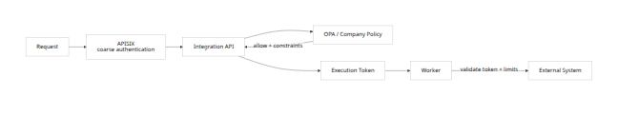
Open Policy Agent is Apache-2.0 and designed as a general-purpose context-aware policy engine, making it suitable as a policy-decision component behind our own policy model. [23]
Policy inputs can include:
actor
tenant
portal
department
role
AI/human/service
delegation
capability
side-effect classification
resource
customer
project
data classification
amount
time
location
connection
Policy outputs should be more expressive than Boolean allow/deny:
{
"decision": "allow",
"constraints": {
"maxRecords": 50,
"readOnly": true,
"requireApprovalAbove": 1000,
"maskFields": ["salary", "nationalId"]
}
}

Secrets design
The Control Plane database should contain only references:
Connection
credential_ref = cred_x7f9
Never:
Connection
password = "..."
refresh_token = "..."
The secret subsystem should support a provider-neutral interface:
interface SecretProvider {
putSecret(...): Promise<SecretRef>;
getForExecution(...): Promise<ExecutionCredential>;
rotate(...): Promise<void>;
revoke(...): Promise<void>;
}
Recommended rules:
- Envelope encryption with KMS/HSM-backed master keys in production.
- Separate encryption context by tenant.
- Encrypt OAuth refresh tokens.
- Never return long-lived credentials to the browser.
- Never include credentials in AI prompts.
- Never include credentials in event payloads.
- Never include credentials in logs/traces.
- Inject credentials only into the worker that requires them.
- Prefer short-lived credentials/tokens.
- Revoke execution grants immediately when a connection is disabled.
For a database, credentials should ideally belong to a dedicated user with:
read-only
or
specific schema/table/procedure grants
rather than a database administrator.

MCP architecture
MCP deserves its own protocol-aware service:
MCP Broker
┌──────────────────┐
Company AI ─────▶│ tool discovery │─────▶ External MCP
│ schema snapshots │
│ authorization │
│ policy mapping │
│ consent │
│ risk classes │
│ tracing │
└──────────────────┘
External MCP Client
│
▼
APISIX
│
▼
Company OS MCP Server
│
▼
Capability Layer
This gives us both directions:
- Company OS consumes MCP servers.
- Company OS itself exposes governed capabilities as MCP tools/resources.
The current MCP specification is version 2026-07-28, and the specification repository is MIT licensed. [35]
The current specification defines MCP tools as model-controlled operations that may interact with databases, APIs and computations. [36]
That makes an important distinction:
MCP is an excellent agent interface. It is not automatically the safest interface for deterministic business transactions.
If an ERP provides both:
POST /invoices
and:
MCP tool: create_invoice
a deterministic workflow should generally call the direct normalized capability.
An AI employee can use the MCP tool when model-directed interaction is genuinely useful.

MCP security requirements
Current MCP authorization requires OAuth 2.1 for authorization servers and Protected Resource Metadata for discovery. [37]
Our broker should enforce:
Server registration
↓
Protocol discovery
↓
Authentication validation
↓
List tools/resources
↓
Snapshot schemas
↓
Risk classification
↓
Admin/policy approval
↓
Expose approved subset
The MCP specification explicitly says tool descriptions/annotations should be considered untrusted unless they come from a trusted server and requires hosts to build consent and access controls around tool invocation. [38]
Therefore:
Never trust an MCP server's declaration that an operation is harmless.
Our catalog determines:
read
write
external communication
financial
destructive
security-sensitive
When a tool catalog changes:
Existing approved tool:
notion.search
New tools discovered:
notion.delete_database
notion.share_workspace
the new capabilities should remain unavailable until policy/review permits them.
MCP also explicitly forbids unsafe credential passthrough patterns for third-party authorization. Current guidance says third-party credentials must not transit through the MCP client and that the MCP server should manage its separate third-party credentials. [39]
For remote MCP:
- Prefer the current HTTP transport.
- Put APISIX in front for transport-level security.
- Put our MCP Broker behind APISIX for protocol policy.
For local stdio MCP:
- Run in isolated connector/edge workers.
- Never launch arbitrary community MCP packages in the central API process.
- Restrict filesystem.
- Restrict environment variables.
- Restrict egress.
- Pin exact package/artifact versions.
MCP's current specification also uses JSON Schema and recommends JSON Schema 2020-12 when no different dialect is declared, which aligns well with our connector-schema direction. [40]

Execution models, reliability, CDC, transformations, and browser fallback
There should not be one execution mode.

Runtime model matrix
Model | Example | Engine | Response model
Synchronous | Read customer | Camel/native worker | Immediate
Async command | Generate large report | Temporal/worker | 202 + runId
Durable workflow | Customer onboarding | Temporal | Long-running
Webhook | Invoice updated | APISIX → JetStream | Fast acceptance
Polling | Check new records every 5 min | Temporal/Camel scheduler | Event output
Event subscription | Customer changed | JetStream | Async
CDC | SQL row changed | Debezium | Continuous
Batch | Import 50m rows | SeaTunnel | Job
Streaming | Continuous high-volume feed | SeaTunnel/Kafka/NATS | Continuous
MCP | AI invokes Notion tool | MCP Broker | RPC/tool invocation
Browser | Old portal form | Playwright worker | Usually async

Synchronous actions
Use only when:
- Work is fast.
- External provider response is reasonably bounded.
- No human approval is involved.
- One immediate result is useful.
Recommended API shape:
POST /v1/capabilities/crm.company.read:execute
Response:
{
"runId": "run_123",
"status": "succeeded",
"result": {
"id": "company_77",
"name": "Example AB"
}
}

Asynchronous actions
If execution can take substantial time:
POST /v1/capabilities/report.generate:execute
returns:
{
"runId": "run_882",
"status": "queued"
}
The client then uses:
GET /v1/runs/run_882
or receives an event.

Reliability baseline
The safest general assumption is:
Messages and work may be delivered more than once.
This is especially important for CDC. Debezium's SQL Server documentation explicitly notes scenarios where source records can be emitted more than once because offsets are persisted periodically. [41]
Therefore:
at-least-once delivery
+
idempotent consumers
+
deduplicated business writes
=
our baseline
Do not market broker-level “exactly once” as equivalent to exactly one business effect.

Transactional outbox
Every important Company OS database transaction that emits an event should use an outbox.
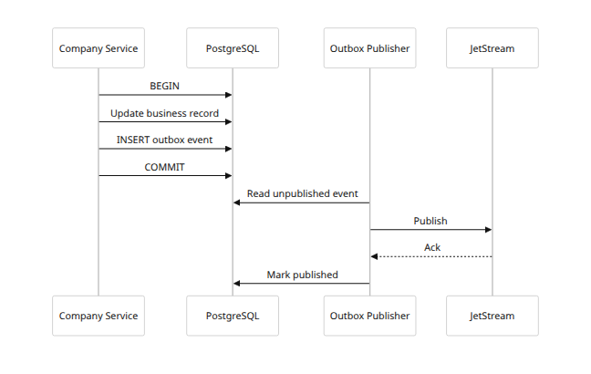
This avoids the classic failure:
DB commit succeeds
↓
process crashes
↓
event never published

Consumer inbox/deduplication
Consumers should maintain:
processed_message
├── tenant_id
├── consumer
├── message_id
├── idempotency_key
├── first_seen_at
└── result_reference
with a uniqueness constraint.
Pseudo-code:
await db.transaction(async (tx) => {
const inserted = await tx.inbox.tryInsert(message.id);
if (!inserted) {
return; // duplicate
}
await performBusinessEffect(tx, message);
});

Idempotency keys
Recommended composition:
tenant_id
+
connection_id
+
capability_id
+
business operation key
or workflow-scoped:
tenant_id:workflow_run_id:step_id
Do not generate a fresh idempotency key on each retry.

Failure taxonomy
Every worker should normalize errors:
Class | Typical cases | Retry
transient_network | Timeout, connection reset | Yes
rate_limited | HTTP 429 | Yes, delayed
upstream_unavailable | 502/503 | Yes
authentication_expired | Refreshable OAuth | Refresh then retry
authentication_revoked | User revoked access | No; intervention
permission_denied | 403 | No
validation_error | 400/schema mismatch | No
not_found | Missing external object | Usually no
conflict | Version/write conflict | Policy dependent
ambiguous_write | Connection lost after submit | Reconcile before retry
permanent | Unsupported operation | No

DLQ design
Dead letters need a durable reference, not an opaque broker dump.
{
"eventId": "evt_92",
"runId": "run_88",
"tenantId": "tenant_a",
"connector": "erpnext",
"connectionId": "conn_7",
"errorClass": "validation_error",
"attempts": 4,
"payloadRef": "encrypted-object://...",
"firstFailure": "...",
"lastFailure": "...",
"replayAllowed": true
}
The UI should support:
Inspect
Retry
Replay with new connector version
Edit mapping and replay
Discard with reason
Escalate

Circuit breakers
Maintain circuit state per:
vendor + connection
not only globally.
Company A's broken Salesforce credentials should not stop Company B.
Camel exposes a Circuit Breaker EIP through its current integration patterns. [42]

CDC deployment patterns
There are two sensible Debezium patterns.
Standard/high-scale pattern:
Database
↓
Debezium Kafka Connect
↓
Kafka
↓
Normalizer
↓
Company event model
Debezium is historically centered around Kafka Connect, and its documentation continues to describe this architecture. [43]
Smaller/edge deployment:
Database
↓
Edge CDC service
↓
Debezium Engine
↓
Normalizer
↓
JetStream / Company OS
Debezium exposes an embeddable Engine API, including asynchronous engine implementations. [44]
The second option avoids forcing Kafka into every small installation, but it transfers more responsibility to us.
Debezium connectors require persistent offset/state storage, and some connectors also maintain schema history that must survive restarts. [45]
Therefore the Edge Runtime must never treat CDC offsets as temporary container files.

CDC object model
CDCConnection
├── database_connection
├── connector_type
├── selected schemas
├── selected tables
├── snapshot mode
├── publication/replication settings
├── offset store
├── schema history store
├── event mapping
├── data classification
├── masking rules
└── lag thresholds
Raw CDC events should not automatically become public Company OS events.
Pipeline:
Debezium event
↓
Schema validation
↓
Table allowlist
↓
Sensitive field masking
↓
Source-specific normalization
↓
Business event mapping
↓
Company event
Example:
postgres.public.invoice UPDATE
becomes:
{
"type": "finance.invoice.updated",
"tenantId": "tenant_1",
"source": {
"system": "legacy_erp",
"table": "invoice",
"id": "9918"
},
"changes": {
"status": {
"before": "sent",
"after": "paid"
}
}
}

CDC versus transactional outbox
For databases we own, prefer an application transaction/outbox.
For external systems we cannot modify, CDC is appropriate.
Do not use CDC as an excuse to ignore semantic application events.
A row changing:
status = 4
does not necessarily tell us whether that means:
invoice paid
invoice cancelled
invoice disputed
That requires a mapping.

Data transformation architecture
Use layered transformations:
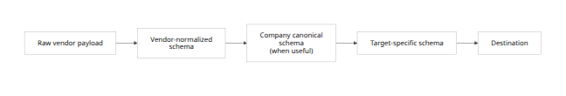
Not every integration needs C.
For example:
Notion page
→ internal AI context
may remain vendor-specific.
But:
Twenty Company
→ Company OS Company
→ ERPNext Customer
benefits from a canonical business object.

Do not build one universal data model
Attempting to normalize every field in every business system will create an enormous abstraction that never quite fits.
Canonicalize high-value domains:
- Person.
- Company.
- Address.
- Product.
- Invoice.
- Project.
- Task.
- File/document.
- Employee.
- Event.
Allow extension fields:
{
"id": "...",
"name": "...",
"extensions": {
"twenty": {
"customRiskScore": 7
}
}
}

Mapping definition
apiVersion: companyos.io/mapping/v1
kind: Mapping
metadata:
id: twenty-company-to-canonical
version: 3
source:
schema: connector://twenty/company/v2
target:
schema: canonical://crm/company/v1
rules:
- from: id
to: externalIds.twenty
- from: name
to: name
- expression: |
source.address?.country ?? null
to: address.country
- expression: |
normalizeDomain(source.domainName)
to: websiteDomain
The mapping runtime should provide:
- Field mapping.
- Constants.
- Conditional expressions.
- Array operations.
- Date/time normalization.
- Currency/decimal handling.
- Lookup tables.
- Reference resolution.
- Controlled reusable functions.
For complex transformations, allow signed code-based transforms, but treat them as connector artifacts with the same security process.
Kaoto's current visual DataMapper work is worth studying/reusing for the mapping editor rather than starting its interaction design from scratch. [20]

Mapping tests
Every mapping version should support fixtures:
tests:
- name: normal-company
input: fixtures/twenty-company.json
expected: fixtures/company.expected.json
- name: missing-address
input: fixtures/twenty-company-no-address.json
expected: fixtures/company-no-address.expected.json
Tests should include:
- Missing fields.
- null.
- Unicode.
- Timezones.
- DST boundaries.
- Decimal precision.
- Currency.
- Empty arrays.
- Very large strings/files.
- Unexpected vendor fields.
- Deleted fields.
- Schema-version upgrades.
- PII redaction.

Browser automation fallback
Browser automation should be marked internally as a less reliable connector class.
browserReliabilityClass: fallback
Every browser connector should declare:
browser:
allowedHosts:
- legacy.example.com
session:
persistent: true
maxAge: PT8H
downloads:
allowed: true
maxSizeMb: 50
uploads:
allowed: false
evidence:
screenshotOnWrite: true
traceOnFailure: true
Execution:
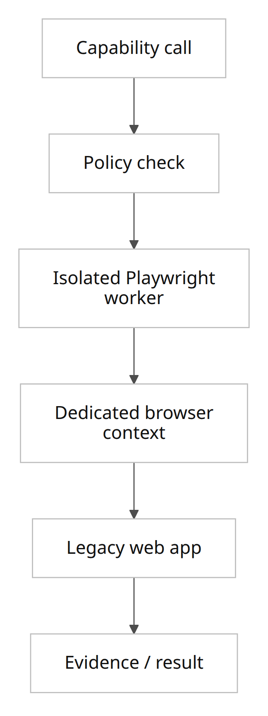
Rules:
- Ephemeral worker wherever possible.
- Dedicated browser context per connection.
- No shared cookies across tenants.
- Domain allowlist.
- Block access to cloud metadata and internal infrastructure.
- No unrestricted filesystem.
- Credentials injected only into the worker.
- Prefer deterministic locators and scripts over unconstrained AI clicking.
- Require stronger review for write operations.
- Capture screenshots/traces of important actions.
- Run synthetic tests regularly to detect UI breakage.
Playwright's current project also includes browser/agent interoperability and MCP-related tooling, but we should use its browser automation APIs as the fundamental primitive rather than couple business-critical integration logic to its agent layer. [46]

Observability, CI/CD, supply chain, SLAs, and upgrades
Integrations fail in more ways than ordinary application requests.
They depend on:
- Our software.
- Our network.
- Customer networks.
- Vendor networks.
- Vendor APIs.
- Credentials.
- OAuth consent.
- Vendor schema changes.
- Mapping versions.
- External quotas.
- Databases.
- Human approvals.
Observability therefore has to be part of the integration model.

Correlation model
Every operation should carry:
trace_id
correlation_id
run_id
step_run_id
tenant_id
portal_id
actor_id
workflow_id
connector_id
connector_version
connection_id
capability_id
idempotency_key
external_request_id
Example:
{
"traceId": "7f...",
"correlationId": "customer_onboarding_982",
"runId": "run_221",
"stepRunId": "step_7",
"tenantId": "tenant_a",
"actorId": "ai_sales_9",
"connectorId": "twenty",
"connectorVersion": "1.4.0",
"connectionId": "conn_17",
"capability": "crm.company.create",
"idempotencyKey": "tenant_a:run_221:step_7"
}
Use OpenTelemetry for distributed tracing/log/metric correlation and standard W3C trace propagation between services. OpenTelemetry's context propagation is designed to correlate distributed telemetry, and W3C Trace Context provides the standard traceparent mechanism for passing trace identity. [47]
Do not put:
- Passwords.
- Access tokens.
- Customer PII.
- Full document contents.
into trace baggage.

Recommended telemetry
Category | Metrics
Gateway | Requests, 4xx, 5xx, latency, blocked requests
Connections | Health, auth expiry, token-refresh failures
Connector | Success %, p50/p95/p99, retries
Vendor | 429 count, 5xx count, latency
Workflow | Running, completed, failed, waiting
Queue | Pending, age, redelivery, DLQ
CDC | Source lag, events/sec, last offset, schema errors
Batch | Rows/sec, bytes/sec, checkpoint
Browser | Login failures, selector failures, navigation errors
MCP | Tool discovery changes, call count, rejected tools
Policy | Allow, deny, require approval
Security | Invalid signatures, blocked egress, secret-access failures

Run trace UI
An engineer or customer administrator should see:
RUN #882
Customer onboarding
09:00:01 Trigger received OK
09:00:01 Signature verified OK
09:00:01 Workflow started OK
09:00:02 Twenty: find company OK 180 ms
09:00:02 ERPNext: create customer OK 320 ms
09:00:03 Drive: create folder RETRY
09:00:05 Drive: create folder RETRY
09:00:10 Drive: create folder OK
09:00:10 Human approval requested WAITING

Initial engineering SLOs
These are recommended targets, not claims about the underlying OSS projects.
Service objective | Initial target
Control-plane API monthly availability | 99.9%
Webhook durable-acceptance availability | 99.95%
Internal gateway/control overhead p95 | <250 ms
Webhook durable acknowledgement p95 | <2 seconds
JetStream event dispatch p95 | <2 seconds in healthy cluster
Normal CDC lag p95 | <10 seconds where source permits
Trace coverage for production runs | >99.9%
Missing actor attribution | 0
Secret values in application logs | 0
Undetected cross-tenant result | 0
External SaaS latency should be reported separately from our internal latency.

Connector supply-chain model
Connectors are executable software with access to customer systems.
Treat each connector release like a product release.
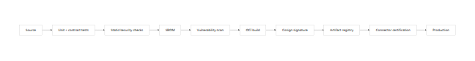
Use Syft to generate CycloneDX/SPDX SBOMs. Syft is Apache-2.0 and supports SBOM generation from container images, filesystems and many package ecosystems. [48]
Use Grype or an equivalent scanner to scan images, filesystems and SBOMs against known vulnerabilities. [49]
Use Cosign for OCI artifact signing. Cosign is Apache-2.0, supports keyless/KMS-backed signing, and its project documentation explicitly recommends signing immutable image digests rather than mutable tags. [50]
Example deployment reference:
BAD:
registry.companyos.io/connectors/twenty:latest
GOOD:
registry.companyos.io/connectors/twenty@sha256:b86d...

Admission requirements
Production connector artifacts should be rejected unless:
Manifest valid
AND
license permitted
AND
SBOM present
AND
artifact signed by approved publisher
AND
digest matches registration
AND
critical vulnerability policy passes
AND
integration tests pass
AND
capability declaration approved

Runtime sandbox
Untrusted/third-party workers should have:
- Non-root user.
- Read-only root filesystem.
- Temporary writable volume only when necessary.
- Memory limit.
- CPU limit.
- Process limit.
- No host filesystem.
- No Docker socket.
- No Kubernetes credentials.
- Network egress allowlist.
- No ambient tenant secrets.
- Short-lived execution token.
- Seccomp/AppArmor or equivalent runtime policy.

Activepieces import policy
Because Activepieces mixes MIT Community Edition with commercially licensed enterprise areas, importing code must have an automated path/license check. [32]
A piece is not production-approved just because its source is available.
Review:
source license
dependency licenses
current vendor API
authentication
token scopes
rate limits
error handling
pagination
PII behavior
tests

Upgrade strategy
Never auto-upgrade an integration engine immediately across the whole fleet.
Use:
upstream release
↓
compatibility environment
↓
our regression suite
↓
security review
↓
internal canary
↓
1–5% tenant canary
↓
controlled rollout
↓
old runtime drained
Camel: remain on a supported LTS for production connector workers unless a newer feature line is specifically needed. Camel maintains upgrade recipes to assist migrations between release families. [51]
APISIX: read each release's breaking-change section. APISIX 3.17 explicitly includes compatibility-impacting changes in authentication, TLS and configuration behavior. [52]
Temporal: server and SDK upgrade compatibility must be tested independently of workflow code. The current 1.31 release line has GA Worker Deployment Versioning facilities, which can help stage worker-code updates. [53]
Debezium: preserve offsets and schema history through upgrades. Connector upgrades must be tested against the database version and schema being captured. Debezium explicitly requires persistent state for connector offsets and, for several databases, schema history. [45]
SeaTunnel: review incompatible-change documentation before upgrades rather than assuming job compatibility. [54]
MCP: store protocol version per server connection. MCP now has a formal evolving specification, so the broker must support protocol negotiation/adaptation rather than assuming today's transport will remain unchanged forever. The July 2026 release itself represents substantial transport/auth changes from earlier versions. [55]
Playwright: browser engine versions move frequently; browser automations should therefore have automated regression runs against the runtime version being promoted. [9]

Developer APIs, SDKs, flow definitions, and implementation tasks
The developer experience should expose our abstraction, regardless of whether Camel, Temporal or Playwright runs underneath.

Public Integration Control Plane API
Recommended resource model:
Endpoint | Purpose
GET /v1/connectors | Connector catalog
GET /v1/connectors/{id} | Connector detail
GET /v1/connectors/{id}/versions | Versions
POST /v1/connections | Create connection
POST /v1/connections/{id}/verify | Test connection
POST /v1/connections/{id}/oauth/start | Begin OAuth
DELETE /v1/connections/{id} | Revoke/remove
GET /v1/connections/{id}/capabilities | Enabled operations
POST /v1/capabilities/{id}:execute | Execute capability
POST /v1/workflows | Create flow
POST /v1/workflows/{id}/versions | Publish revision
POST /v1/workflows/{id}:activate | Activate
POST /v1/workflows/{id}:pause | Pause
POST /v1/workflows/{id}/runs | Start run
GET /v1/runs/{id} | Inspect run
POST /v1/runs/{id}:cancel | Cancel
POST /v1/runs/{id}:retry | Retry failure
POST /v1/runs/{id}:replay | Replay
GET /v1/runs/{id}/steps | Step trace
POST /v1/mappings | Create mapping
POST /v1/mappings/{id}:test | Test mapping
POST /v1/mcp/connections | Register MCP server
POST /v1/mcp/connections/{id}:discover | Discover tools/resources
POST /v1/mcp/connections/{id}:approveChanges | Approve tool changes
GET /v1/events/subscriptions | Event subscriptions
POST /v1/webhook-endpoints | Create incoming webhook

Capability execution API
Request:
POST /v1/capabilities/crm.company.create:execute
Idempotency-Key: 90dd...
{
"connectionId": "conn_twenty_01",
"input": {
"name": "Example AB",
"domain": "example.se"
},
"context": {
"customerId": "cust_221",
"projectId": "proj_71"
}
}
Response:
{
"runId": "run_842",
"status": "succeeded",
"output": {
"id": "external_183",
"name": "Example AB"
},
"external": {
"system": "twenty",
"requestId": "..."
}
}
The caller should not supply an authoritative tenant or actor ID in the body. Those should come from the authenticated request context.

Connector SDK
I recommend a TypeScript SDK as the primary custom-connector SDK because it matches the likely Company OS application stack and makes it easier to reuse selected Activepieces logic.
A Java/Camel adapter exposes the same contract for Camel components.
Conceptually:
export interface ConnectorContext {
readonly tenantId: string;
readonly connectionId: string;
readonly runId: string;
readonly traceId: string;
http: ScopedHttpClient;
secrets: ExecutionSecretHandle;
checkpoint: CheckpointStore;
idempotency: IdempotencyService;
events: EventEmitter;
logger: RedactingLogger;
}
export interface Action<I, O> {
definition: ActionDefinition;
run(ctx: ConnectorContext, input: I): Promise<O>;
}
export interface Trigger<O> {
definition: TriggerDefinition;
start(
ctx: TriggerContext,
emit: (event: O) => Promise<void>
): Promise<void>;
}
The SDK's http object should enforce allowed hosts from the connector manifest.
Do not expose unrestricted:
fetch(anyUrl)
to third-party connectors by default.

SDK project types
companyos-connector-sdk
├── HTTP/OpenAPI connector
├── webhook trigger
├── polling trigger
├── file trigger
├── database capability
├── Camel adapter
├── MCP adapter
├── Activepieces compatibility adapter
├── browser automation adapter
└── test harness

Connector CLI
Engineers should have:
companyos connector init
companyos connector validate
companyos connector test
companyos connector test-auth
companyos connector test-webhook
companyos connector sbom
companyos connector build
companyos connector sign
companyos connector publish

Local emulator
A developer should not need a production Company OS cluster to write a connector.
companyos dev connector ./connectors/acme
should provide fake:
- Tenant context.
- Secret broker.
- Idempotency service.
- Event bus.
- Checkpoint storage.
- Approval service.

Integration test contract
Every production connector should pass standard tests:
connect
authenticate
read
write
pagination
rate limit
timeout
token expiry
token revocation
bad input
provider 4xx
provider 5xx
duplicate request
network disconnect
schema variation
large response
PII logging

Example flow definition
apiVersion: companyos.io/workflow/v1
kind: IntegrationWorkflow
metadata:
id: new-customer-onboarding
version: 7
trigger:
type: event
event: crm.customer.created
steps:
- id: lookup-erp-customer
capability: erp.customer.search
connection: "${connections.erp}"
input:
email: "${trigger.customer.email}"
- id: create-if-missing
if: "${steps.lookup-erp-customer.output.count == 0}"
capability: erp.customer.create
connection: "${connections.erp}"
idempotencyKey: "${run.id}:erp-customer"
input:
name: "${trigger.customer.name}"
email: "${trigger.customer.email}"
- id: create-drive-folder
capability: documents.folder.create
connection: "${connections.drive}"
idempotencyKey: "${run.id}:drive-folder"
input:
name: "${trigger.customer.name}"
- id: request-approval
type: approval
when: "${trigger.customer.riskScore >= 8}"
approverRole: customer-risk-manager
- id: publish
type: event
event: customer.onboarding.started
Temporal can compile/execute the durable control logic while Camel/native workers perform the individual external capabilities.

Example MCP exposure
The same capability can be exposed to AI through MCP:
Native capability:
crm.company.search
MCP tool presented to permitted AI:
companyos.crm.company.search
The model sees only the schema and capability allowed by policy.
It does not receive:
- CRM API key.
- Vendor admin token.
- Database password.
- Internal connector endpoint.

Example private database execution
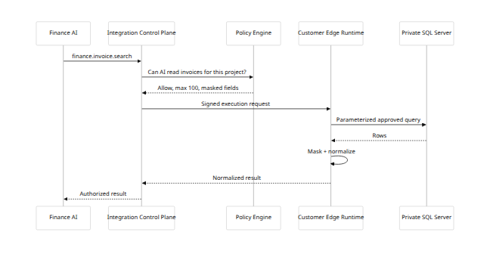

ERPNext/Frappe adapter
Frappe currently generates REST endpoints for all DocTypes and supports RPC-style whitelisted methods, making an API-first ERPNext/Frappe connector practical. [56]
The connector should support:
doctype.search
doctype.read
doctype.create
doctype.update
method.call
webhook.subscribe/configure
but expose higher-level Company OS capabilities where stable semantics exist.

Twenty adapter
Twenty currently exposes both REST and GraphQL APIs generated from the workspace schema, including custom objects, plus webhooks and OAuth. [57]
This makes Twenty useful for testing:
- REST.
- GraphQL.
- Dynamic schemas.
- Rate limits.
- Custom objects.
- Webhooks.
- OAuth/API-key patterns.

Developer implementation workstreams
Workstream | Main engineering tasks
Control Plane | Data model, API, versions, capabilities, connections
Security | Policy engine, execution tokens, secret broker
Gateway | APISIX configuration/control integration
Connector SDK | TS SDK, CLI, emulator, test harness
Camel runtime | Worker contract, route templates, health
Temporal | Workflow compiler/runtime, approvals, cancellation
Events | NATS/JetStream, schemas, outbox/inbox
MCP | Client broker, server exposure, discovery/governance
Edge Runtime | Registration, outbound control channel, updater
CDC | Debezium orchestration and normalization
Bulk | SeaTunnel job adapter
Browser | Playwright sandbox/worker
Mapping | Schema registry, mapping language/editor
Observability | OTel, run traces, metrics, alerting
Supply chain | Build/sign/scan/certification
UI | Connections, catalog, workflows, mapping, runs, incidents

Proof of concept, acceptance criteria, risk matrix, effort, and implementation checklist
The POC should prove the architecture, not merely demonstrate three successful API calls.

Recommended POC topology
Company OS Integration Control Plane
├── PostgreSQL
├── OPA
├── APISIX
├── Temporal
├── NATS JetStream
├── Camel workers
├── MCP Broker
├── connector registry
├── local encrypted secret provider
└── OpenTelemetry
Test systems
├── ERPNext / Frappe
├── Twenty
├── Gmail / Google Drive
├── remote PostgreSQL
├── Debezium
├── mock MCP server
└── mock legacy web app
SeaTunnel can be a separate POC track rather than a hard dependency of the first architecture demonstration.

POC scenarios
Scenario | What it proves
ERPNext read/write through REST | API connector
ERPNext signed webhook | Webhook ingress
Twenty REST query | REST
Twenty GraphQL query | GraphQL
Twenty custom object discovery | Dynamic schema
Gmail/Drive operation | OAuth cloud integration
Remote PostgreSQL read | JDBC
Remote DB write with constrained user | DB governance
Debezium PostgreSQL CDC | CDC
NATS event fan-out | Event backbone
Temporal approval wait | Durable workflow
MCP external tool discovery | MCP client
Company capability exposed via MCP | MCP server
Legacy test site through Playwright | Browser fallback
Worker running in edge network | Private integration
Frappe supplies automatically generated DocType REST APIs and signed webhook support, so it is well suited for the API/webhook side of the POC. [58]
Twenty exposes both REST and GraphQL against workspace-specific schemas, so it provides a useful second API style and dynamic-schema test. [34]
Camel's current catalog includes Google Mail and Google Drive components, allowing Gmail/Drive to exercise OAuth-oriented cloud connectivity without making those services core architectural dependencies. [59]

Failure-injection test suite
The POC is not accepted until the following are exercised.
Failure | Expected behavior
Connector process killed before API request | Automatic retry
Worker killed after external write but before local ack | No duplicate business effect
Same webhook sent 100 times | One logical effect
Provider returns 429 | Backoff, no DLQ yet
Provider returns permanent 400 | Immediate permanent failure
OAuth token expires | Refresh where allowed
OAuth connection revoked | Connection becomes unhealthy
Secret disabled | Execution blocked
NATS node restarted | Durable events continue
Temporal worker restarted | Workflow resumes
Edge runtime disconnected | Work waits/retries
Database inaccessible | Circuit opens after policy threshold
CDC service restarted | Resumes from durable offset
Duplicate CDC event | One downstream effect
Source schema adds field | Compatible handling
Source schema removes required field | Mapping failure/DLQ
MCP server adds destructive tool | Tool not automatically exposed
MCP server changes schema | Requires revalidation
Browser selector changes | Connector marked unhealthy
Cross-tenant ID injected | Access denied
AI attempts forbidden capability | Policy denies
Connector attempts unexpected network host | Egress denied

POC acceptance criteria
Tenancy
0 confirmed cross-tenant data leaks
0 ability to use another tenant's connection
0 ability to access another tenant's credential
Reliability
duplicate event tests produce one business effect
worker crash does not lose acknowledged business work
Temporal workflows resume after worker restart
CDC resumes from stored checkpoint
DLQ is inspectable and replayable
Security
no secret in logs
no secret in traces
no raw long-lived credential reaches an AI prompt
network egress policy blocks unauthorized destinations
unsigned connector image cannot be deployed
MCP tool changes do not bypass approval
Observability
>99.9% of POC integration runs have a complete correlation path
every failed run identifies failing connector and step
external provider request IDs are retained when available
Developer experience
new basic REST connector can be created using SDK template
connector can be tested locally
manifest validation is automatic
SBOM generated automatically
signed artifact promoted automatically after tests

Suggested POC timeline
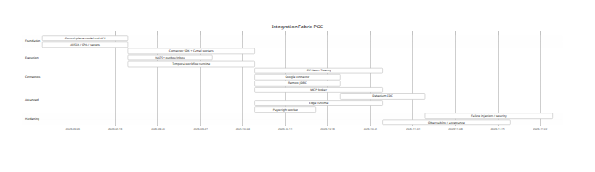
The dates are illustrative; the important point is the dependency order.

Estimated engineering effort
These are planning estimates, not promises.
Stage | Team | Calendar estimate | Person-effort
Architectural spike | 2–3 senior engineers | 2–3 weeks | 5–8 person-weeks
Credible POC | 5–7 engineers | 10–14 weeks | 50–80 person-weeks
Hardened internal alpha | 7–9 engineers | additional 3–4 months | 100–150 person-weeks
Production v1 integration fabric | 8–12 engineers + SRE/security | 6–9 months total after POC direction is validated | 220–380 person-weeks
Broad enterprise integration platform | 10–15 engineers | 12–18 months | 450–800+ person-weeks
These estimates exclude building hundreds of polished vendor connectors.
Using Camel and selectively adapting Activepieces connectors should reduce connector-development effort substantially, but every imported connector still needs recertification.

Principal risks
Risk | Probability | Impact | Mitigation
Cross-tenant data leakage | Medium | Critical | Signed tenant context, worker isolation, policy tests
Credential leakage | Medium | Critical | Secret broker, redaction, no prompt credentials
Third-party connector compromise | Medium | Critical | SBOM, signing, sandbox, egress controls
Direct DB write damages customer system | Medium | Critical | Read-only default, approved capabilities, transactions
Duplicate side effects | High | High | Idempotency, inbox/outbox, reconciliation
Vendor API breaking changes | High | Medium–High | Versioned connectors, contract tests, canaries
MCP tool changes expand authority | High | High | Tool snapshots and reapproval
MCP malicious descriptions/tool metadata | Medium | High | Treat metadata as untrusted, local risk classification
CDC duplicate/change ordering issue | Medium | High | Idempotency, partition ordering, durable offsets
CDC schema drift | High | Medium–High | Schema registry, compatibility tests, DLQ
Browser UI changes | Very high | Medium–High | Last-resort status, health tests, evidence
Integration infrastructure becomes too complex | Medium | High | Do not deploy specialist engines until required
Temporal lock-in in workflow definitions | Medium | Medium | Keep Company OS workflow DSL independent
Camel route logic becomes business logic | Medium | High | Camel only executes connector operations
Activepieces license boundary accidentally crossed | Medium | High | Automated path/license scanning
Customer firewall prevents cloud worker access | High | High | Edge Runtime
Event “exactly once” assumption is wrong | High | High | Design for at-least-once and idempotency

Recommended production rollout order
The architecture should be implemented incrementally:
FIRST
Integration Control Plane
APISIX
OPA
Connector contract
Secrets abstraction
Camel
REST/OpenAPI
Webhooks
JDBC
NATS JetStream
ERPNext + Twenty
↓
SECOND
Temporal
MCP Broker
Google/Microsoft cloud connectors
Email
SFTP/SMB
Edge Runtime
Mapping framework
↓
THIRD
Debezium CDC
Advanced SOAP/gRPC
Connector marketplace/import pipeline
Kaoto-derived visual tools
↓
WHEN REQUIRED
SeaTunnel
High-volume streaming infrastructure
Playwright legacy automation
Dedicated tenant execution clusters
This avoids repeating the problem seen in Open Integration Hub: deploying a large collection of infrastructure services before actual customer workloads require all of them.

Implementation checklist
Area | Required before production
Architecture | ☐ Control plane independent from execution engines
 | ☐ Stable Company OS Capability model
 | ☐ Connectors and connections separated
 | ☐ Flow model independent of Temporal
Tenancy | ☐ Server-derived tenant context
 | ☐ No caller-controlled authoritative tenant IDs
 | ☐ Cross-tenant automated attack tests
 | ☐ Per-tenant connection ownership
AI governance | ☐ Human/AI/service principal differentiation
 | ☐ AI capability limits
 | ☐ Delegation chain
 | ☐ Approval gates for high-risk actions
Secrets | ☐ KMS/envelope encryption
 | ☐ Secrets referenced, never stored in manifests
 | ☐ OAuth rotation/revocation
 | ☐ No credentials in prompts/logs/events
Connectors | ☐ Versioned connector manifests
 | ☐ JSON Schema inputs/outputs
 | ☐ Side-effect classification
 | ☐ Idempotency declaration
 | ☐ Rate-limit declaration
 | ☐ Network egress declaration
Runtime | ☐ Camel execution provider
 | ☐ Temporal durable provider
 | ☐ JetStream durable events
 | ☐ Execution cancellation/timeouts
 | ☐ Circuit breakers
Reliability | ☐ Transactional outbox
 | ☐ Consumer inbox/dedupe
 | ☐ Retry taxonomy
 | ☐ DLQ
 | ☐ Manual replay
 | ☐ Ambiguous-write reconciliation
MCP | ☐ Current protocol support
 | ☐ OAuth/resource validation
 | ☐ Server/tool snapshots
 | ☐ Tool-change review
 | ☐ Risk classification independent of server metadata
 | ☐ No token passthrough
 | ☐ stdio servers sandboxed
Database | ☐ Read-only default
 | ☐ Schema/table allowlists
 | ☐ Parameterized capabilities
 | ☐ Query timeout
 | ☐ Dedicated database identity
CDC | ☐ Durable offsets
 | ☐ Durable schema history
 | ☐ Sensitive field filtering
 | ☐ Duplicate-event testing
 | ☐ Schema-drift handling
Edge Runtime | ☐ Outbound-only connectivity option
 | ☐ mTLS/device identity
 | ☐ Remote revoke
 | ☐ Signed updates
 | ☐ Local execution isolation
Browser | ☐ Isolated Playwright workers
 | ☐ Domain restrictions
 | ☐ Separate browser contexts
 | ☐ Screenshot/trace evidence
 | ☐ Automated health regression
Mapping | ☐ Immutable mapping versions
 | ☐ Fixtures and golden tests
 | ☐ Schema compatibility
 | ☐ Currency/date/timezone testing
Observability | ☐ OpenTelemetry
 | ☐ Correlation IDs
 | ☐ Run/step trace UI
 | ☐ Vendor IDs captured
 | ☐ Queue/CDC/browser metrics
Supply chain | ☐ SBOM
 | ☐ Vulnerability scan
 | ☐ Licence scan
 | ☐ OCI digest pinning
 | ☐ Cosign signature verification
 | ☐ Egress policy
Upgrade | ☐ Connector canary mechanism
 | ☐ Runtime compatibility suite
 | ☐ Rollback
 | ☐ Temporal worker-version strategy
 | ☐ MCP protocol-version compatibility
The final architectural principle should be kept very strict:
COMPANY OS
knows companies, humans, AI employees,
scopes, roles, authority and business meaning
│
▼
INTEGRATION CONTROL PLANE
knows capabilities, connections, policies,
mappings, flows, runs and external identities
│
▼
EXECUTION PROVIDERS
Camel │ Temporal │ NATS │ MCP │ Debezium │ SeaTunnel │ Playwright
│
▼
ANY SYSTEM
API │ DB │ MCP │ SOAP │ GraphQL │ gRPC │ Mail │ SFTP │ SMB
Cloud │ Webhook │ Queue │ CDC │ Files │ Browser
Camel, Temporal, NATS, Debezium, APISIX and MCP are infrastructure. The strategic product is the governed semantic layer above them.
That is what allows the Company OS to remain stable when one customer uses Twenty and ERPNext, another uses Salesforce and SAP, another uses Notion and Microsoft 365, and another still runs a fifteen-year-old SQL database and exchanges invoices through SFTP.
The Company OS should see capabilities and company authority.
The integration fabric should absorb the technical differences.

[1] [10] Components - Apache Camel
https://camel.apache.org/components/4.18.x/index.html?utm_source=chatgpt.com
[2] Downloads - Apache Camel
https://camel.apache.org/download/?utm_source=chatgpt.com
[3] [52] Release Apache APISIX 3.17.0
https://apisix.apache.org/blog/2026/06/15/release-apache-apisix-3.17.0/?utm_source=chatgpt.com
[4] GitHub - temporalio/temporal: Temporal service · GitHub
https://github.com/temporalio/temporal?utm_source=chatgpt.com
[5] [28] JetStream | NATS Docs
https://docs.nats.io/nats-concepts/jetstream?utm_source=chatgpt.com
[6] [22] [35] Specification and documentation for the Model Context ...
https://github.com/modelcontextprotocol/modelcontextprotocol?utm_source=chatgpt.com
[7] [17] Debezium 3.6.1.Final Released
https://debezium.io/blog/2026/08/04/debezium-3-6-1-final-released/?utm_source=chatgpt.com
[8] [19] [30] Releases · apache/seatunnel
https://github.com/apache/seatunnel/releases?utm_source=chatgpt.com
[9] [46] microsoft/playwright: Playwright is a framework ...
https://github.com/microsoft/playwright?utm_source=chatgpt.com
[11] GraphQL - Apache Camel
https://camel.apache.org/components/4.18.x/graphql-component.html?utm_source=chatgpt.com
[12] REST OpenApi - Apache Camel
https://camel.apache.org/components/4.18.x/rest-openapi-component.html?utm_source=chatgpt.com
[13] JDBC - Apache Camel
https://camel.apache.org/components/4.18.x/jdbc-component.html?utm_source=chatgpt.com
[14] oas-validator | Apache APISIX
https://apisix.apache.org/docs/apisix/plugins/oas-validator/?utm_source=chatgpt.com
[15] Webhooks - Frappe Documentation
https://docs.frappe.io/framework/user/en/guides/integration/webhooks?utm_source=chatgpt.com
[16] SFTP - Apache Camel
https://camel.apache.org/components/4.18.x/sftp-component.html?utm_source=chatgpt.com
[18] Releases · nats-io/nats-server · GitHub
https://github.com/nats-io/nats-server/releases?utm_source=chatgpt.com
[20] Kaoto 2.11 release - The Integration Designer for Apache Camel
https://kaoto.io/blog/2026/kaoto-2.11-release/?utm_source=chatgpt.com
[21] [33] Releases · activepieces/activepieces · GitHub
https://github.com/activepieces/activepieces/releases
[23] open-policy-agent/opa
https://github.com/open-policy-agent/OPA?utm_source=chatgpt.com
[24] [42] Resilience4j EIP - Apache Camel
https://camel.apache.org/components/4.18.x/eips/resilience4j-eip.html?utm_source=chatgpt.com
[25] Apache Camel Security Advisory - CVE-2026-46590 - Apache Camel
https://camel.apache.org/security/CVE-2026-46590.html?utm_source=chatgpt.com
[26] openid-connect - Apache APISIX
https://apisix.apache.org/docs/apisix/plugins/openid-connect/?utm_source=chatgpt.com
[27] Multi-tenancy - Temporal feature
https://docs.temporal.io/evaluate/development-production-features/multi-tenancy?utm_source=chatgpt.com
[29] Source Connectors :: Debezium Documentation
https://debezium.io/documentation/reference/stable/connectors/index.html?utm_source=chatgpt.com
[31] GitHub - KaotoIO/kaoto: The UI of the Kaoto project · GitHub
https://github.com/KaotoIO/kaoto
[32] GitHub - activepieces/activepieces: AI Agents & MCPs & AI Workflow Automation • (~400 MCP servers for AI agents) • AI Automation / AI Agent with MCPs • AI Workflows & AI Agents • MCPs for AI Agents · GitHub
https://github.com/activepieces/activepieces?utm_source=chatgpt.com
[34] [57] APIs - Twenty Documentation
https://docs.twenty.com/developers/extend/api?utm_source=chatgpt.com
[36] Tools
https://modelcontextprotocol.io/specification/2026-07-28/server/tools?utm_source=chatgpt.com
[37] Authorization
https://modelcontextprotocol.io/specification/2026-07-28/basic/authorization?utm_source=chatgpt.com
[38] Specification
https://modelcontextprotocol.io/specification/2026-07-28?utm_source=chatgpt.com
[39] Elicitation
https://modelcontextprotocol.io/specification/2026-07-28/client/elicitation?utm_source=chatgpt.com
[40] Overview
https://modelcontextprotocol.io/specification/2026-07-28/basic?utm_source=chatgpt.com
[41] Debezium connector for SQL Server
https://debezium.io/documentation/reference/stable/connectors/sqlserver.html?utm_source=chatgpt.com
[43] Build a Superfast CDC with Debezium, Quarkus and ...
https://debezium.io/blog/2025/03/12/superfast-debezium/?utm_source=chatgpt.com
[44] Debezium Engine
https://debezium.io/documentation/reference/stable/development/engine.html?utm_source=chatgpt.com
[45] Storing state of a Debezium connector
https://debezium.io/documentation/reference/stable/configuration/storage.html?utm_source=chatgpt.com
[47] Context propagation
https://opentelemetry.io/docs/concepts/context-propagation/?utm_source=chatgpt.com
[48] GitHub - anchore/syft: CLI tool and library for generating a Software Bill of Materials from container images and filesystems · GitHub
https://github.com/anchore/syft?utm_source=chatgpt.com
[49] anchore/grype: A vulnerability scanner for container ...
https://github.com/anchore/grype?utm_source=chatgpt.com
[50] GitHub - sigstore/cosign: Code signing and transparency for containers and binaries · GitHub
https://github.com/sigstore/cosign?utm_source=chatgpt.com
[51] apache/camel-upgrade-recipes
https://github.com/apache/camel-upgrade-recipes?utm_source=chatgpt.com
[53] Releases · temporalio/temporal · GitHub
https://github.com/temporalio/temporal/releases?utm_source=chatgpt.com
[54] Incompatible Changes - Apache SeaTunnel
https://seatunnel.apache.org/docs/introduction/concepts/incompatible-changes/?utm_source=chatgpt.com
[55] The 2026-07-28 Specification
https://blog.modelcontextprotocol.io/posts/2026-07-28/?utm_source=chatgpt.com
[56] [58] REST API - Frappe Documentation
https://docs.frappe.io/framework/user/en/api/rest?utm_source=chatgpt.com
[59] Tika - Apache Camel
https://camel.apache.org/components/4.18.x/tika-component.html?utm_source=chatgpt.com

